Chapter 19, Solution 71.

This is a parallel-series connection of two two-ports. We need to add their g parameters together and obtain z parameters from there.

For the transformer,

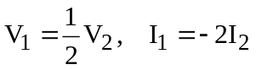

Comparing this with

shows that

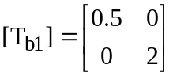

To get A and C for T_{b2} , consider the circuit below.

I₁ 4 I₂ =0

+ +
5
V₁ V₂
- 2 -

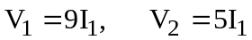

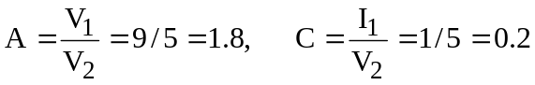

We obtain B and D by looking at the circuit below.

I₁ 4 I₂ =0

+ +
5
V₁ V₂=0
- 2 -

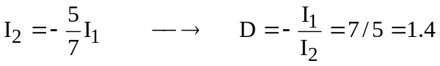

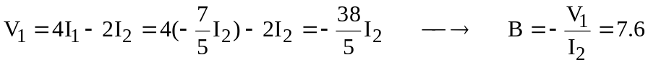

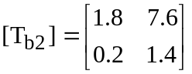

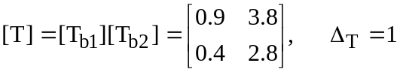

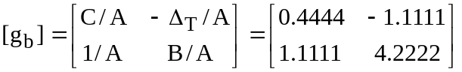

From Prob. 19.52,

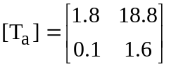

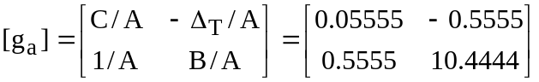

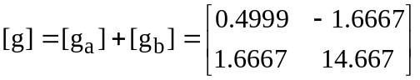

Thus,

